Address: http://freetuts.net/cau-lenh-if-else-trong-mysql-273.html

delimiter $$

**drop** **procedure** **if** **exists** checkLogin $$

**create** **procedure** checkLogin(

input_username **varchar**(255),

input_password **varchar**(255),

**out** result **varchar**(255)

)

**begin**

*/*Bien flag luu tru level. Mac dinh la -1*/*

**declare** flag **int**(11) **default** -1;

*/*Thuc hien truy van gan level vao bien flag*/*

**select** us_level **into** flag **from** members

**where** us_username = input_username **and** us_password = **MD5**(input_password);

*/*Sau khi thuc hien lenh select nay ma khong co du lieu thi*

*luc nay flag se khong thay doi. Chinh vi the neu flag = -1 tuc la sai thong tin */*

**IF** (flag = -1) **then** **set** result = 'Thong tin dang nhap sai';

**ELSEIF** (flag = 0) **then** **set** result = 'Tai khoan bi khoa';

**ELSEIF** (flag = 1) **then** **set** result = 'Tai khoan admin';

**ELSE** **set** result = 'Tai khoan member';

**end** **if**;

**end** $$

delimiter ;

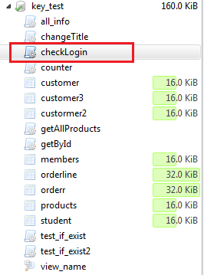

Gọi procedure ra:

**call** checkLogin('admin', 'vancuong', @result);

**select** @result;

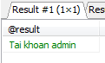

**call** checkLogin('member', 'vancuong', @result);

**select** @result;



**call** checkLogin('banded', 'vancuong', @result);

**select** @result;



**call** checkLogin('another', 'vancuong', @result);

**select** @result;

